EXECUTION ORDER FORM

To order development Form based on : Payment transaction

Module : Finance
Sub Module : Bank Accounting
Name of Functional Specification : E-Payment (BNI)

Signed by:

< Fadia Hadyani Putri > < Erpan Gustira >

< Heni Mulyani > < Munaji >

<Integration Team Lead>

Additional Program

General Status Information
Reference ID. | -
Spec ID
Priority | After Go-Live
Version | 1.0
Business Owner
Description | E-Payment BNI
Prepared By | Fadia Hadyani Putri
Estimated Development Time | 9 hari
Date of Creation | 11 Agustus 2023
Date (last modified)
T-Code | Z31FIW004

Name of Closest SAP Form

Reason why not using the Standard SAP
Standard SAP tidak ada fasilitas generate outgoing payment sesuai dengan format bank BNI.

Business Specifications and Requirements

Business Requirements Description
E-Payment BNI digunakan untuk melakukan upload pembayaran ke pihak luar PT.KSP.

Business Requirements Specifications
Detail Requirements Definition.

Selection Criteria

Selection Field | S/P | M/O | Field Table | Check
- | - | - | - | -

M/O : M = mandatory, O = Optional
S/P: S = (select-options) from-to, P = single value select (parameter)

Data Dictionary Used.
Table Name | Table Description | Insert | Delete | Query | Update
BKPF | Accounting Document Header
BSEG | Accounting Document Segment
BSIK | Accounting – Secondary Index for Vendors
BSAK | Accounting – Secondary Index for Vendors (cleared items)
EKKO | Purchasing Document Header
LFA1 | Vendor Master (General Data)

Custom Data Dictionary.
Field Name | Description | Data Type | Length | Decimals
- | - | - | - | -

Reference Program: KDL - Z21FIW001

Layout A (View Batch):
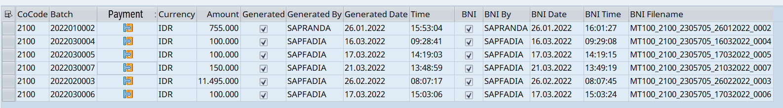

Proses Detail Layout A (View Batch):
No | Column | Field-Table | Remarks
1. | Company Code | BKPF - BUKRS | Select BUKRS from BKPF where BUKRS = ‘3100’
2. | Batch |  | Hasil generate dari list outgoing payment, format:  YYYYMMDD + sequence number
3. | Payment | BSAK-AUGBL | Select AUGBL from BSAK where AUGBL = 15* → Terisi jika sudah di generate batch
4. | Curr. | BSAK-WAERS | Select WAERS from BSAK where AUGBL = 15*
5. | Amount | BSAK-PSWBT | Select PSWBT from BSAK where AUGBL = 15*
6. | Generated |  | Akan otomatis terisi apabila sudah generate dokumen
7. | Generated By |  | User ID yang melakukan generate file
8. | Generated Date |  | Tanggal melakukan generate file
9. | Generate Time |  | Waktu ketika generate file
10. | BNI by |  | User ID yang melakukan generate file
11. | BNI date |  | Tanggal file di generate
12. | BNI Time |  | Waktu file di generate
13. | BNI filename |  | Penamaan file BNI:  Untuk KSP: MT100_3100_DDMMYYYY_XXXX

Layout B (Kolom Payment):
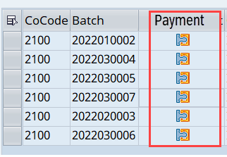

Proses Detail Layout B (Kolom Payment):
No | Column | Field-Table | Remarks
1. | Company Code | BKPF - BUKRS | Select BUKRS from BKPF where BUKRS = ‘3100’
2. | Invoice |  | Hasil generate dari list outgoing payment, format:  YYYYMMDD + sequence number
3. | Name Vendor | LFA1 – NAME1 | - Select LIFNR from BSAK where BSCHL = 31 and AUGBL ≠ 15*  - Go to table LFA1 input LIFNR get data NAME1
4. | Year | BSAK - GJAHR | Select GJAHR from BSAK where AUGBL = 15*
5. | Payment | BSAK - AUGBL | Select AUGBL from BSAK where AUGBL = 15*
6. | Currency | BSAK - WAERS | Select WAERS from BSAK where AUGBL = 15*
7. | Amount | BSAK - PSWBT | Selecr PSWBT from BSAK where AUGBL = 15*
8. | Via Bank | BNKA - BANKA | - Select ALTKT from BSEG where BELNR = 15*  - Go to table T012K, input HKONT = PSWBT get data HBKID  - Go to table T012, input HBKID get data BANKL  - Go to table BNKA input BANKL get data BANKA
9. | Via Bank Account | T012K - BANKN | - Select ALTKT from BSEG where BELNR = 15*  - Go to table T012K, input HKONT = PSWBT get data BANKN
10. | Rejected |  | Tanda √ jika terjadi reject
11. | Rejected By |  | User ID yang melakukan reject
12. | Rejected Date |  | Tanggal transaksi di reject
13. | Rejected Time |  | Waktu transaksi di reject

Layout C (Generate Batch):

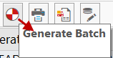

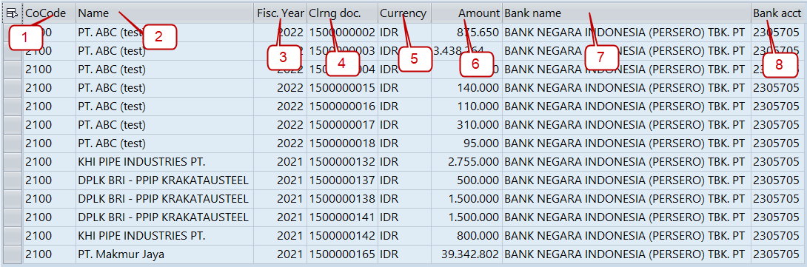

Process Detail Form Layout C (Generate Batch):
No | Column | Field-Table | Remarks
1. | Company Code | T001 - BUKRS | Select BUKRS from T001 where BUKRS = ‘3100’
2. | Name Vendor | LFA1 – NAME1 | - Select LIFNR from BSAK where BSCHL = 31 and AUGBL ≠ 15*  - Go to table LF  - A1 input LIFNR get data NAME1
3. | Year | BSAK-GJAHR | Select GJAHR from BSAK where AUGBL = 15*
4. | Clearing Document | BSAK - AUGBL | Select AUGBL from BSAK where AUGBL = 15*
5. | Currency | BSAK - WAERS | Select WAERS from BSAK where AUGBL = 15*
6. | Amount | BSAK - PSWBT | Select PSWBT from BSAK where AUGBL = 15* and BCSHL = 25
7. | Bank Name | BNKA - BANKA | - Select ALTKT from BSEG where BELNR = 15*  - Go to table T012K, input HKONT = PSWBT get data HBKID  - Go to table T012, input HBKID get data BANKL  - Go to table BNKA input BANKL get data BANKA
8. | Bank Account | T012K - BANKN | - Select ALTKT from BSEG where BELNR = 15*  - Go to table T012K, input HKONT = PSWBT get data BANKN

Layout D (Ikon Invoice 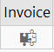):

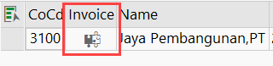

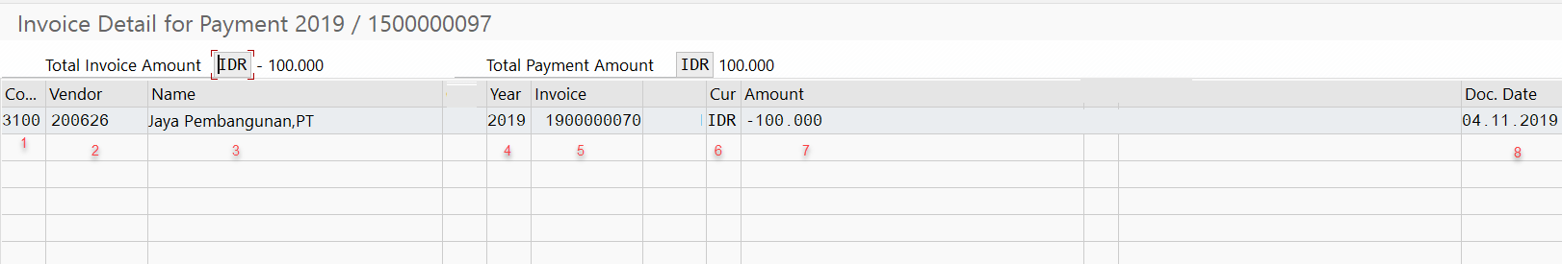

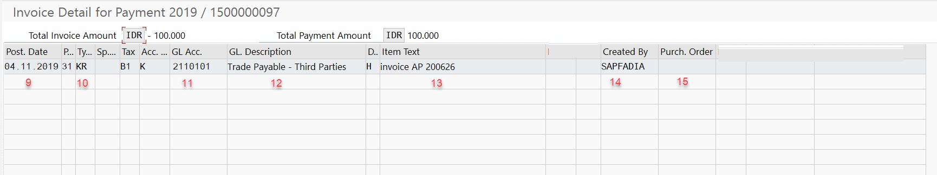

Process Detail Form Layout D (Ikon Invoice):
No | Column | Field-Table | Remarks
1. | Company Code | T001 - BUKRS | Select BUKRS from T001 where BUKRS = ‘3100’
2. | Vendor | BSAK - LIFNR | Select LIFNR from BSAK where BSCHL = 31, BELNR = 19*, 51*, atau 10*
3. | Name | LFA1 – NAME1 | - Select LIFNR from BSAK where BSCHL = 31 and AUGBL ≠ 15* (atau BELNR = 19*, 51* atau 10*)  - Go to table LFA1 input LIFNR get data NAME1
4. | Year | BSAK - GJAHR | Select GJAHR from BSAK where AUGBL ≠ 15* and BSCHL = 31
5. | Invoice | BSAK - BELNR | Select BELNR from BSAK where AUGBL ≠ 15*
6. | Currency | BSAK - WAERS | Select WAERS from BSAK where AUGBL ≠ 15* and BELNR = 19*, 51*, 10*
7. | Amount | BSAK - PSWBT | Select PSWBT from BSAK where AUGBL ≠ 15* and BSCHL = 31, BELNR = 19*, 51*, 10*
8. | Doc. Date | BSAK - BLDAT | Select BLDAT from BSAK where AUGBL ≠ 15* and BSCHL =31, BELNR = 19*, 51*, 10*
9. | Posting Date | BSAK - BUDAT | Select BUDAT from BSAK where AUGBL ≠ 15* and BSCHL =31, BELNR = 19*, 51*, 10*
10. | Doc Type | BSAK - BLART | Select BLART = KZ, RE, AB from BSAK where AUGBL ≠ 15* and BSCHL =31, BELNR = 19*, 51*, 10*
11. | G/L Account Hutang | BSAK - SAKNR | Select SAKNR from BSAK where AUGBL ≠ 15* and BSCHL =31, BELNR = 19*, 51*, 10*
12. | GL Description | SKA1 – TXT50 | - Select SAKNR from BSAK where AUGBL ≠ 15* and BSCHL =31, BELNR = 19*, 51*, 10*  - Go to table SKA1 input SAKNR get data TXT50 where KTOPL = KOCA
13. | Item Text | BSAK - SGTXT | Select SGTXT from BSAK where AUGBL ≠ 15* and BSCHL =31, BELNR = 19*, 51*, 10*
14. | Created By | BKPF - USNAM | - Select BELNR from BSAK where AUGBL ≠ 15*  - Go to table BKPF input BELNR get data USNAM
Hasil Output Naming File BNI File:

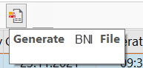

MT100 + Company Code + DDMMYYYY + Sequence Number

Contoh: MT100_3100_11082023_0001

Keterangan:
1. MT100 → kode dari BNI
2. 3100 → kode company code PT KSP
3. DDMMYYYY → format tgl generate
4. Sequence Number: 0001 (max 4 digit)

Process Detail Hasil Output Naming File BNI Direct:
No | Column | Field-Table | Remarks
1. | Format file |  | Harcode: MT100_3100 → ambil dari table Z (mohon dibuatkan table Z untuk nampung nomor rekening beserta filename)  Contoh: Z21FIDT015  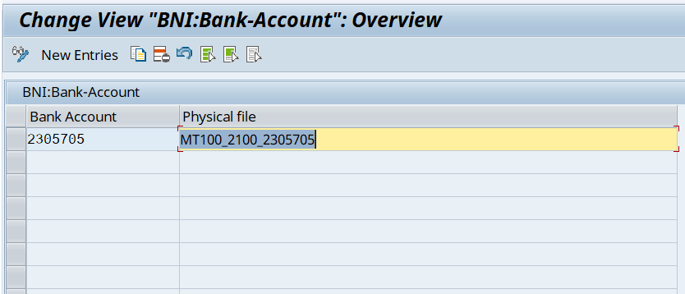

Format Output BNI Direct:
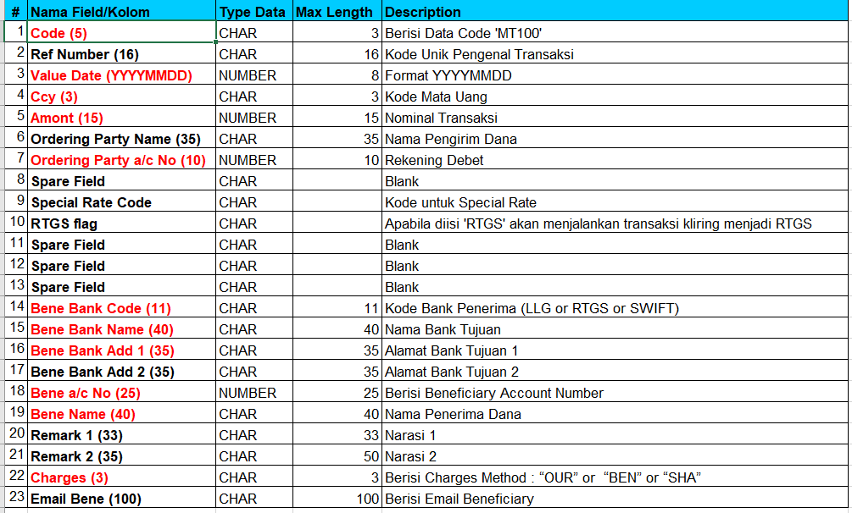

Proses Detail Output BNI Direct dalam bentuk .csv:
No | Field | Table | M/O | Remarks
1. | Code (5) | - | M | Hardcode: MT100
2. | Ref Number (16) | BSAK - AUGBL | O | Select AUGBL from BSAK where AUGBL = 15*
3. | Value Date (YYYYMMDD) |  | M | Select BUDAT from Z-table new SPT  Format: YYYYMMDD
4. | Ccy (3) | BSAK - WAERS | M | Select WAERS from BSAK where AUGBL = 15*
5. | Amount (15) | BSAK - PSWBT | M | Select PSWBT from BSAK where AUGBL = 15*
6. | Ordering Party Name (35) |  | O | Hard code ‘PT Krakatau Sarana Properti’
7. | Ordering Party a/c No (10) | T012K - BANKN | M | - Select ALTKT from BSEG where BELNR = 15*  - Go to table T012K, input HKONT = PSWBT get data BANKN
8. | Spare Field |  | O
9. | Special Rate Code |  | O
10. | RTGS flag |  | O
11. | Spare Field |  | O
12. | Spare Field |  | O
13. | Spare Field |  | O
14. | Bene Bank Code (11) | BNKA-SWIFT | M | - Select LIFNR from BSAK where AUGBL = 15*  - Go to table LFBK, isi LIFNR ambil BANKL  - Go to table BNKA, isi BANKL ambil data SWIFT
15. | Bene Bank Name (40) | BNKA-BANKA | M | - Select LIFNR from BSAK where AUGBL = 15*  - Go to table LFBK, isi LIFNR ambil BANKL  - Go to table BNKA, isi BANKL ambil data BANKA
16. | Bene Bank Add 1 (35) | BNKA-STRAS | M | - Select LIFNR from BSAK where AUGBL = 15*  - Go to table LFBK, isi LIFNR ambil BANKL  - Go to table BNKA, isi BANKL ambil data STRAS
17. | Bene Bank Add 2 (35) |  | O
18. | Bene a/c No (25) | LFBK-BANKN | M | - Select LIFNR from BSAK where AUGBL = 15*  - Go to table LFBK, isi LIFNR ambil BANKN
19. | Bene Name (40) |  | M | - Select LIFNR from BSAK where AUGBL = 15*  - Go to table LFBK, isi LIFNR ambil KOINH
20. | Remark 1 (33) |  | O
21. | Remark 2 (55) |  | O | Select SGTXT from BSAK, where AUGBL = 15* and BSCHL = 25
22. | Charges (3) |  | M | Karena KSP yang menanggung (dibebankan kepada pengirim) maka di hardcode OUR
23. | Email Bene (100) |  | O

Pada saat simulasi rencana pembayaran BNI via Program ‘LIST OF PAYMENT’

From Layout E:

Work list
Desain layout D



Layout E

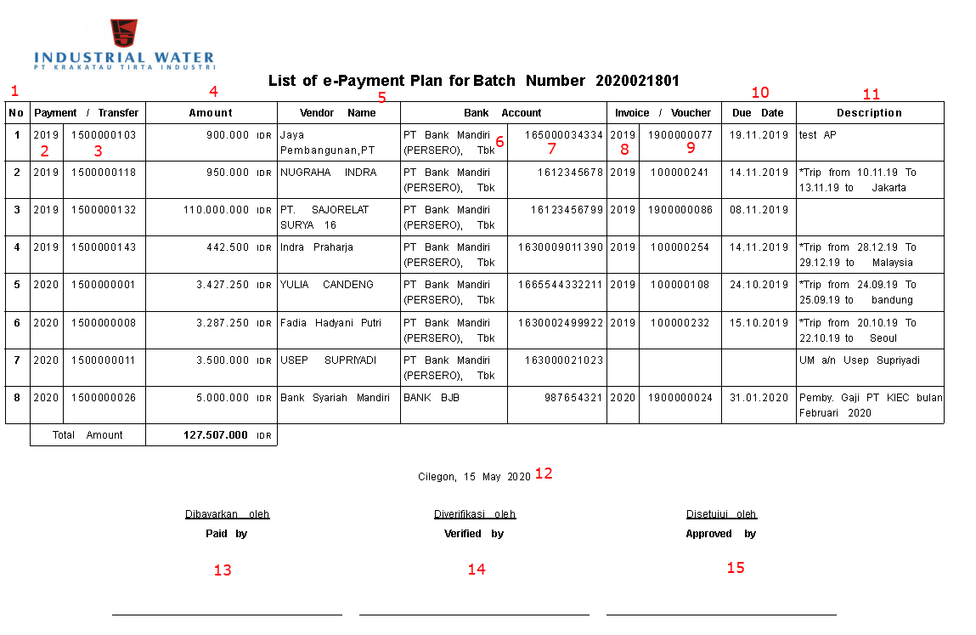

Process Detail Form Daftar Rencana Pembayaran E-Payment:
No | Field | Field-Table | Remarks
1. | No.
2. | Fiscal Year | BSAK-GJAHR | Select GJAHR from BSAK where AUGBL = 15*
3. | Doc. Transfer | BSAK - AUGBL | Select AUGBL from BSAK where AUGBL = 15*
4. | Amount | BSAK - PSWBT | Select PSWBT from BSAK where AUGBL = 15* and BCSHL = 25
5. | Vendor Name | LFA1 – NAME1 | - Select LIFNR from BSAK where BSCHL = 31 and AUGBL ≠ 15*  - Go to table LFA1 input LIFNR get data NAME1
6. | Nama Bank | BNKA - BANKA | - Select LIFNR from BSAK where AUGBL = 15*  - Go to table LFBK, isi LIFNR ambil BANKN  - Go to table BNKA, input BANKL = BANKN get data BANKA
7. | No. rekening | LFBK - BANKN | - Select LIFNR from BSAK where AUGBL = 15*  - Go to table LFBK, isi LIFNR ambil BANKN
8. | Tahun Invoice | BSAK - GJAHR | Select GJAHR from BSAK where AUGBL ≠ 15* and BSCHL = 31
9. | No. Voucher | BSAK - BELNR | Select BELNR from BSAK where AUGBL ≠ 15* and BSCHL = 31*
10. | Due Date | BSEG - NETDT | - Select AUGBL from BSAK where AUGBL = 15*  - Select BELNR from BSAK where AUGBL ≠ 15* and BSCHL = 31*  - Go to table BSEG input BELNR, where BSCHL = 31 get data NETDT
11. | Description | BSEG - SGTXT | - Select AUGBL from BSAK where AUGBL = 15*  - Select BELNR from BSAK where AUGBL ≠ 15* and BSCHL = 31*  - Go to table BSEG input BELNR, where BSCHL = 31 get data SGTXT
12. | Kota, Tanggal |  | SY-DATUM
13. | Dibayarkan Oleh
14. | Diverifikasi Oleh
15. | Approved By

Sort Options
N/A

Authorization Restriction
N/A

Form output (please tick [√] where applicable).

Below is a list on how a form can be executed.

 | Output determination | Description
 | Via an add-on screen
√ | Area menu
√ | Independently (SA38 or SE38)
 | Download to file
√ | Others
 | Output Type Assigned

Printer (please tick [√] where applicable)

Paper Size : A4 Letter Other.........
Paper Orientation : Portrait Landscape

√ | Dot-matrix
 | Laser
 | Others

Expected Result from Form :

Transaction / Batch Job that will access Form :
N/A

Security Issues
N/A

Notes / Assumptions
N/A

Issue # | Description | Resolution

Functional Test
Form: |  | Test date:
Developer: |  | Tel no:
Team member responsible for testing:

- Test file(s): (optional)

- Is the program in line with the functional specification?
Yes No
If “Yes”, sign the form in the appropriate section below. If necessary, add some comments in the ‘General comments’ section.
If “No”, describe the errors in the program here.

Developer responsible:

- Describe the solution(s) :

- New completion date:

Comments after second test (if the program contained errors after first test):

Date: / /

General comments:

Names and signatures:

_____________________________________________________________________________________
Functional consultant

_____________________________________________________________________________________
User

_____________________________________________________________________________________
Developer

